Math 4 Name__________________________________

**5-3 Derivative at a Point**  Date________

*I can use the definition of derivative to compute derivatives*

*I can use derivatives and their graphs to identify properties of functions*

**Part 1:** The projectile referred to in Investigation 1 had a position equation of *h*(*t*) = 960*t* – 16*t*2. Part of the path of the projectile is shown below. In addition, secant lines representing your computations from parts a – d (after the **example** in the U7 L1 I1 investigation) have been drawn. They are so close together, they look like one line.

1. What is happening to the distances between the points on the curve that are connected by the

secant lines as Δ*t* gets smaller?

Eventually the 2 points become one; what results is a **tangent line**. *The slope of the tangent line is the instantaneous velocity (rate of change) of the object at that point in time.*

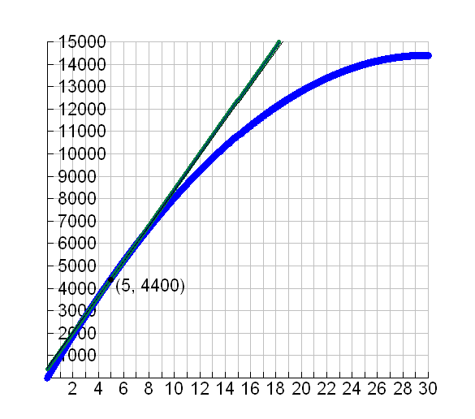 **tangent line**

Calculate the slope of the tangent line when *t* = 5.

Look back at your limit statement from investigation 1. Do the numbers match?

*Height (ft)*

*Time (seconds)*

1. The example in part A illustrates the geometric definition of **instantaneous velocity**. Here is the

algebraic definition:

Suppose an object is moving so that each time *t* it is at a position *f*(*t*) along a line. The **instantaneous velocity** is the limit as Δ*t* → 0 of the average velocity of the object between times *t* and *t* + Δ*t.* In symbols, this means:



**Instantaneous Velocity =**

**Recall:** The formula for the average velocity of the projectile from Investigation 1: ***AV* = 960 – 32t – 16Δ*t*** Use the formula to find the *instantaneous velocity* of the projectile at *t =* 5 seconds.

Finish: *IV* = 

=

C. The graph below shows the distance *d* in miles traveled by a car *t* hours after it begins a trip. Find the **instantaneous velocity** of the car at *t* = 1 hour.

**Part 2:** The previous examples used the quantity  This quantity arises in many other settings, so it has been given a special name. It is called the **derivative of *f* at *x.***

**Definition:** The **derivative of a real function *f* at *x,*** denoted***f’*(*x*)** is:



*Note: The function must be continuous and smooth at point x. This is something you’d learn more about in a full calculus class.*

**Example:** Let 

*Method A: Algebraic*

Follow these steps:

1. Use the definition to derive a formula for **

2. Evaluate your formula when *x =* 2.

*[](http://www.google.com/imgres?hl=en&safe=active&biw=1280&bih=929&tbm=isch&tbnid=Nws9YnZ4YbQcpM:&imgrefurl=http://compasstech.com.au/TNS_Authoring/poly.html&docid=qzgNDPMLLAl4NM&imgurl=http://compasstech.com.au/TNSINTRO/TI-NspireCD/HTML_files/Nspire_logo.jpg&w=913&h=210&ei=nOw4UfGwJvCLyAHf_IHQBw&zoom=1&ved=1t:3588,r:8,s:0,i:103&iact=rc&dur=603&page=1&tbnh=60&tbnw=264&start=0&ndsp=22&tx=110&ty=20)Method B: Graphical ­-style*

Follow these steps:

1. In a new document (NOT “Scratchpad”) graph the function: 

2. If necessary, adjust the window to see the parabola.

3. Press **[MENU]→8: Geometry→1 :Points & Lines→7: Tangent** to open the Tangent Line tool.

4. Click **[CLICK]** on the function graph, then press **[CLICK]** again to construct the tangent line.

5. Press **[ESC]** to exit the Tangent Line tool.

6. Press **[MENU]→1: Actions→8 :Coordinates and Equations**. **[CLICK]** on the point of tangency.

The coordinate of the point should now be displayed.

7. Hold the **[CLICK]** until the hand closes. Drag the point of tangency. Note what happens to the slope of the tangent line as the point of tangency moves along the function.

8. Press **[ESC]** to “let go” of the point of tangency.

9. Double **[CLICK]** on the *x*-coordinate of the displayed point; delete the *x*-coordinate and enter and *x*-coordinate of 2; Press **[ENTER]** to enter the coordinate.

7. Press **[MENU] →** **8: Geometry→3: Measurement→3: Slope**. **[CLICK]** on the tangent line. The slope of the tangent line will be shown.

8. Press **[ESC]** to exit the Slope tool.

*What is the slope of the tangent line at x = 2?*

How does this answer compare to the answer you got the problem at the bottom of the previous page?